**Retail inbound scan Process.**

1. Scan drop-off Number or consignment number into the scan field.
2. Retrieve from CA if is a drop-off number, else retrieve from cx_order_master for consignment (CA/CIT both supported), place into table listing. (Add manual consignment supported)
3. Gets into each consignment (edit) , to complete the mandatory field for calculation. – Get calculation from existing CA table same as Client App based on the chargeable weight.
4. Confirm Payment after shipment details completed, and if is prepaid, send trigger for socket to ask user confirm payment on client app.
5. Client app portion: if prepaid balance insufficient, top up amount.
6. Lock screen with loading after user press confirm payment for 30 second until user confirm, if no confirmation then exit lock for user retry.
7. If is non-prepaid users, direct go to complete status and also call FM API to update status to Sovy.

http://27.131.53.78:8899/api/order/pushstatus

{

AccountKey: "", <-leave blank

CompanyCode: "FXFX", <- Follow Company Code in CIT

LoginId: "fmx", <- Follow UserID

ProgramId: "1", <- Fix as 1

Indicator: "1", <- Fix as 1

Scans:[

{

ConsignmentNo: "MYX1003006924", <- Consignment Number

CustomerReference: "", <- leave blank

Status: "112", <- Fix as 112

TimeStamp: "11/15/2018 16:00 PM", <- Get Today’s datetime

Remark:"", <- leave blank

TotalQuantity: 0, <- Leave zero

Recipient:"", <- Leave blank

RecipientIc: "", <- Leave blank

Weight: "0", <- Leave zero

DutyAmount:"0", <- Leave zero

Location:"Shah Alam", <- Follow Company’s City

DeliveredLocation:"" <- Leave blank

}]

}

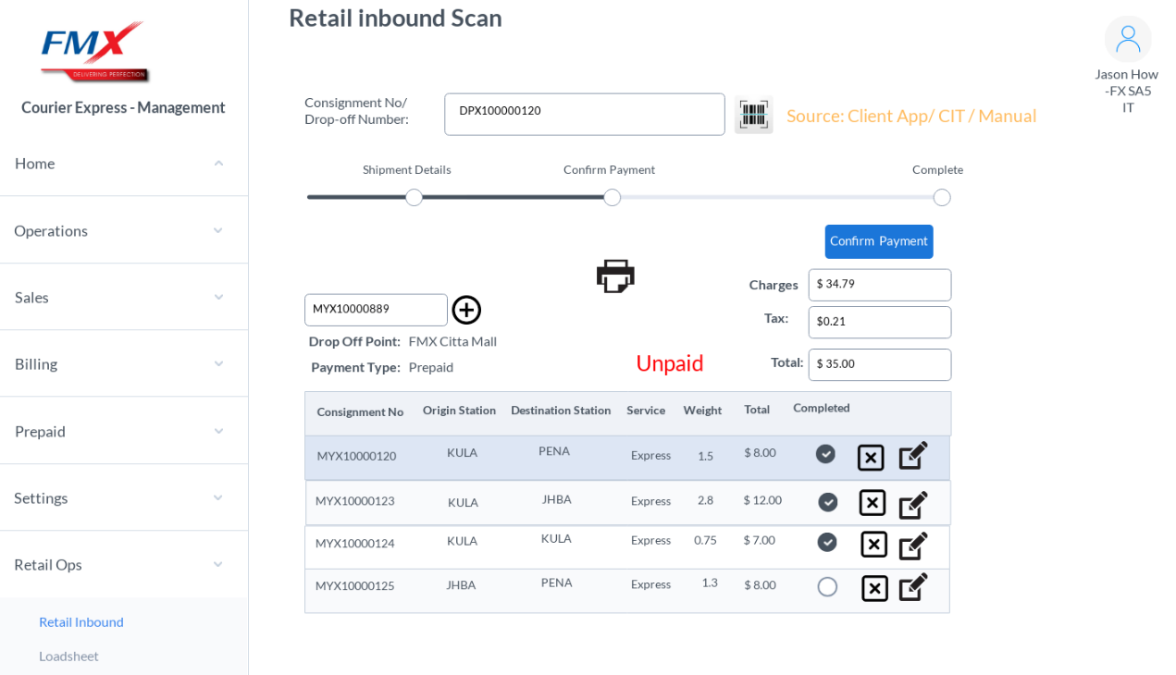

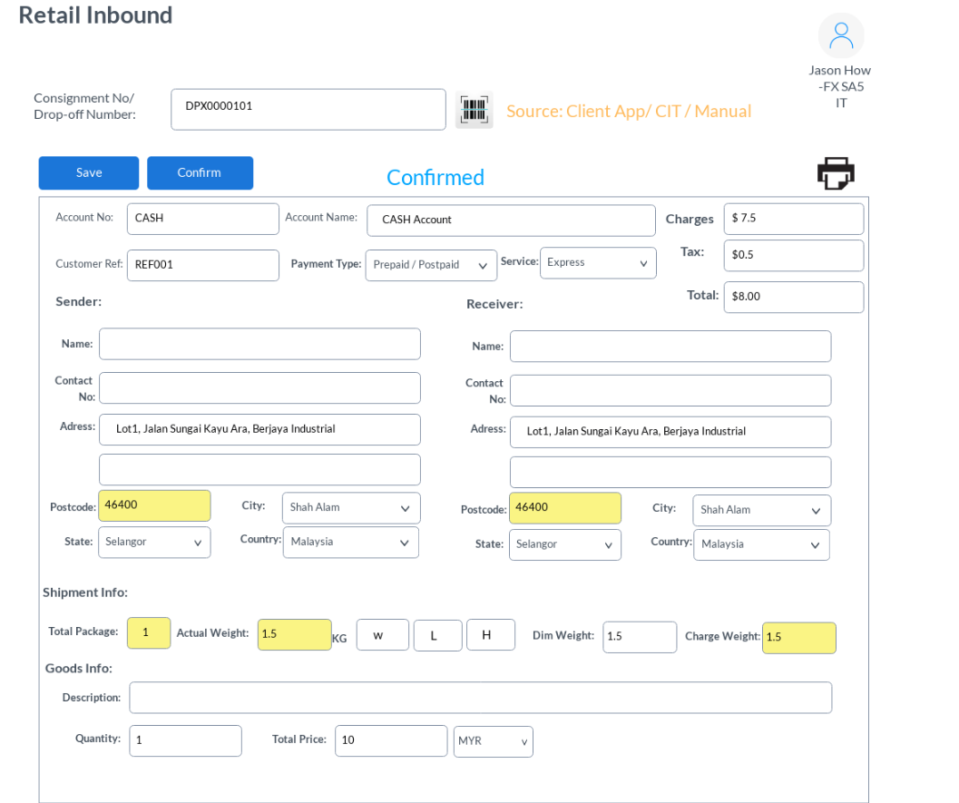

**Retail loadsheet Print**

1. Place in loadsheet number, call FM API to get loadsheet detail.
2. Populate loadsheet information into header and table details.
3. Allow user print runsheet format or manifest format.

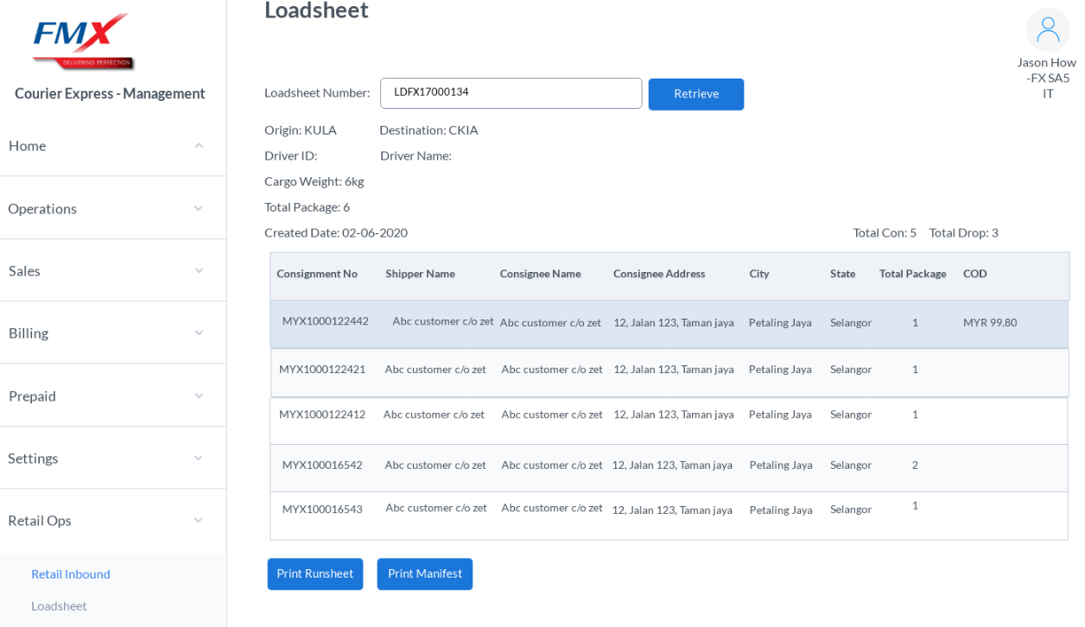

<http://27.131.53.78:8899/api/order/GetLoadInfo>

{

"CompanyCode":"FXFX",

"LoadNumber":"LDFX17000134"

}

Sample return

{

    "LoadHeader": {

        "LoadID": "LDFX17000134",

        "TotalCon": "4",

        "TotalDrop": "3",

        "Origin": "KULA",

        "Destination": "CKIA",

        "DriverId": "",

        "DriverName": "",

        "CargoWeight": "6.0000",

        "TotalPackage": "6",

        "CreateDate": "Sep  5 2017 12:00AM",

        "EditDate": "Sep  5 2017 12:00AM"

    },

    "LoadDetail": [

        {

            "APIStatus": "SUCCESS",

            "LoadID": "LDFX17000134",

            "ConsignmentNo": "MY1001454842",

            "ShipperName": "FEDERAL EXPRESS SERVICES (M) SDN BHD",

            "ConsigneeName": "PETRONAS CARIGALI S/B",

            "Add1": "KEMAMAN SUPPLY BASE",

            "Add2": "",

            "Add3": "",

            "City": "Cukai",

            "State": "Terengganu",

            "Zip": "24007",

            "Country": "MY",

            "TelNo": ".",

            "MobileNo": "",

            "CargoWeight": "1.000000",

            "COD": "0.0000",

            "DOReturn": "0",

            "Remark": "",

            "TotalNumOfPackages": "1"

        },

        {

            "APIStatus": "SUCCESS",

            "LoadID": "LDFX17000134",

            "ConsignmentNo": "MY1001454876",

            "ShipperName": "FEDERAL EXPRESS SERVICES (M) SDN BHD",

            "ConsigneeName": "SANGGUL EMAS S/B",

            "Add1": "C/P PRO INCREASE,",

            "Add2": "KEMAMAN SUPPLY BASE",

            "Add3": "",

            "City": "Cukai",

            "State": "Terengganu",

            "Zip": "24007",

            "Country": "MY",

            "TelNo": ".",

            "MobileNo": "",

            "CargoWeight": "1.000000",

            "COD": "0.0000",

            "DOReturn": "0",

            "Remark": "",

            "TotalNumOfPackages": "1"

        },

        {

            "APIStatus": "SUCCESS",

            "LoadID": "LDFX17000134",

            "ConsignmentNo": "MY1001454868",

            "ShipperName": "FEDERAL EXPRESS SERVICES (M) SDN BHD",

            "ConsigneeName": "EXXONMOBIL EXPL & PRO INC",

            "Add1": "KEMAMAN SUPPLY BASE",

            "Add2": "",

            "Add3": "",

            "City": "Cukai",

            "State": "Terengganu",

            "Zip": "24007",

            "Country": "MY",

            "TelNo": ".",

            "MobileNo": "",

            "CargoWeight": "3.000000",

            "COD": "0.0000",

            "DOReturn": "0",

            "Remark": "",

            "TotalNumOfPackages": "3"

        },

        {

            "APIStatus": "SUCCESS",

            "LoadID": "LDFX17000134",

            "ConsignmentNo": "MY1001454850",

            "ShipperName": "FEDERAL EXPRESS SERVICES (M) SDN BHD",

            "ConsigneeName": "PRO INCREASE",

            "Add1": "KEMAMN SUPPLY BASE",

            "Add2": "",

            "Add3": "",

            "City": "Cukai",

            "State": "Terengganu",

            "Zip": "24007",

            "Country": "MY",

            "TelNo": ".",

            "MobileNo": "",

            "CargoWeight": "1.000000",

            "COD": "0.0000",

            "DOReturn": "0",

            "Remark": "",

            "TotalNumOfPackages": "1"

        }

    ]

}